Primesale orgill instruction 06.03.22  
I.Orgill section  
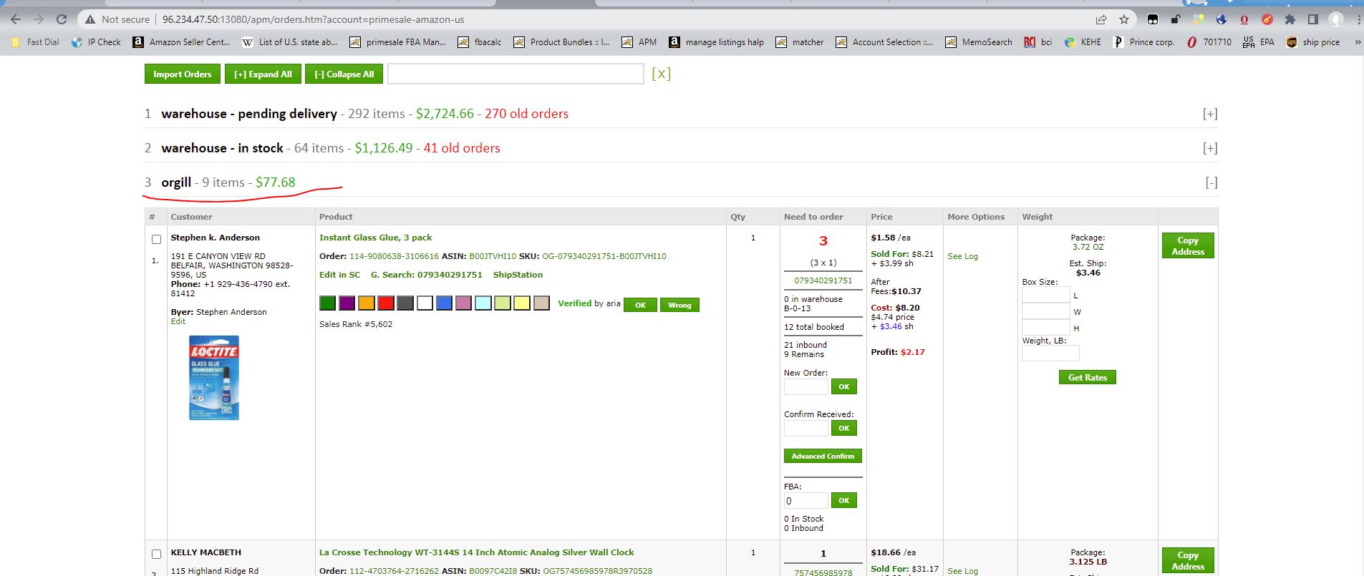  
  
1. we order what comes every 3 hours, make an average order for 15 different products.  
Until the moment of ordering, we simply add the desired product to the cart and wait for the next reports until we collect 15 different products in cart.

Only if you see that, for example, we have an order for 1 pc., and orgill has 1 pc. or 2 pcs. left, add 2 pcs. and do not wait 3 hours, make an order immediately, it does not matter if 15 items are added to cart or not. More examples: we have an order for 5 pieces, and there are 6 left on orgill – we buy 6. We have an order for 10, and there are 12 left on orgill, we buy 12.  
  
2. If the goods are in sufficient quantity on orgill and do not approach out of stock, then we buy only what the customers bought, moreover, we take only if orgill sells the minimum quantity more than we need. (for example, we need 2 pcs., but orgill at least allows us to add 4 to the basket, we buy 4 pcs.)  
  
3. the quantity of goods added to the cart must be recorded in the new order field in APM and click ok.  
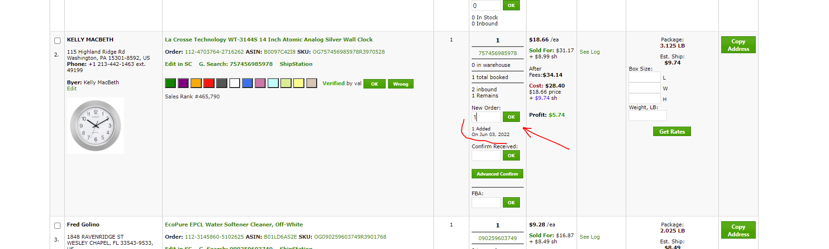  
  
How to order orgill:  
1. In the browser for the bestbrandsupply Amazon account, open the APM  
<http://96.234.47.50:13080/apm/orders.htm?account=primesale-amazon-us>  
2. Go to the seller amazon central unshipped orders  
https://sellercentral.amazon.com/order-reports-and-feeds/reports/unshippedOrders#  
there we click request  
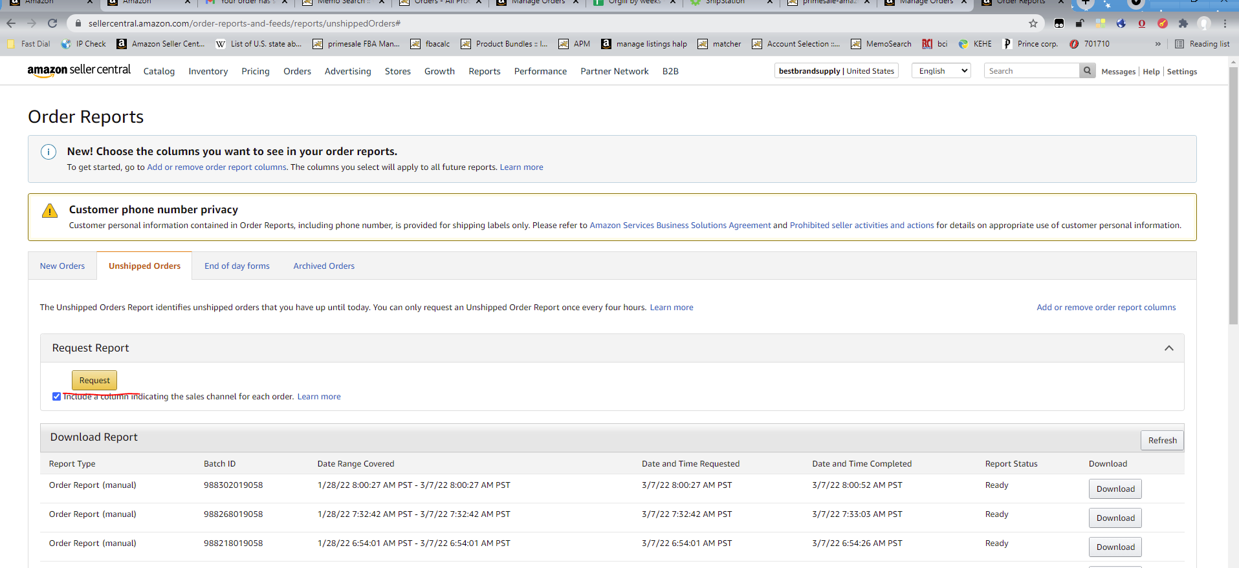  
3. After that, click refresh and use the download button to save the report to your computer  
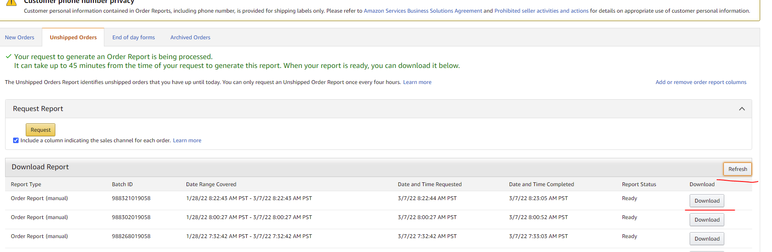  
4.Upload the report to the apm using the import orders button, selecting source: unshipped order report (note the blank and blue colors)  
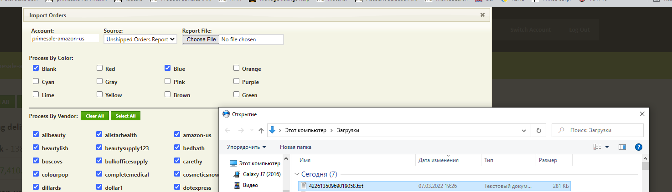  
  
  
5.Do verify products if necessary  
6. Go to orgill  
<https://www.orgill.com/Default.aspx>  
Login: primesale

Pass: 2832__Liza2  
7.Click on the product link in the apm:  
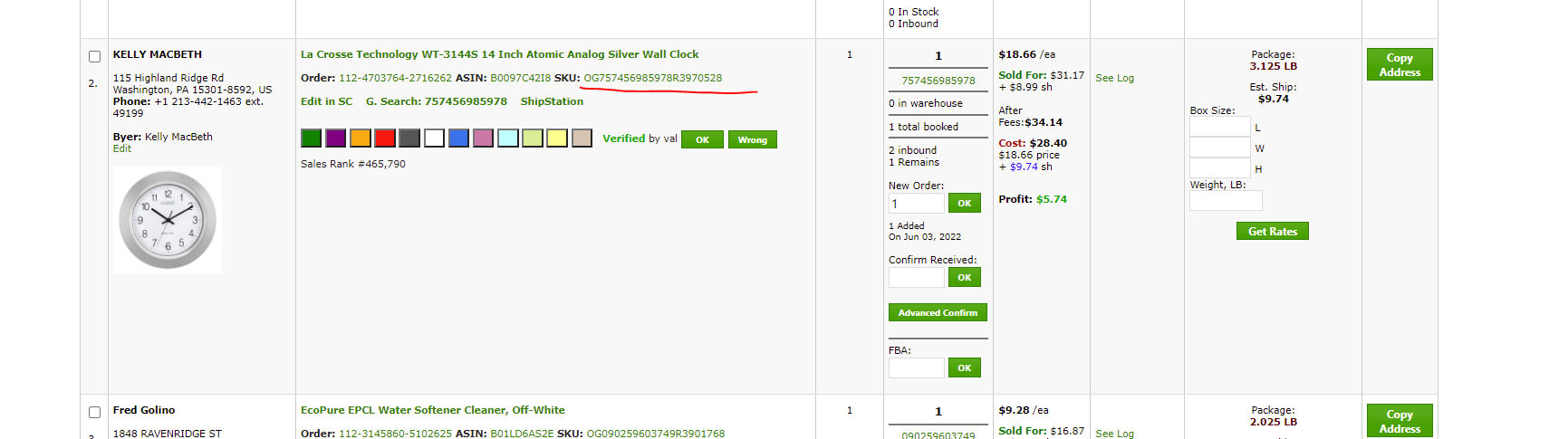  
8.We see the product on orgill  
  
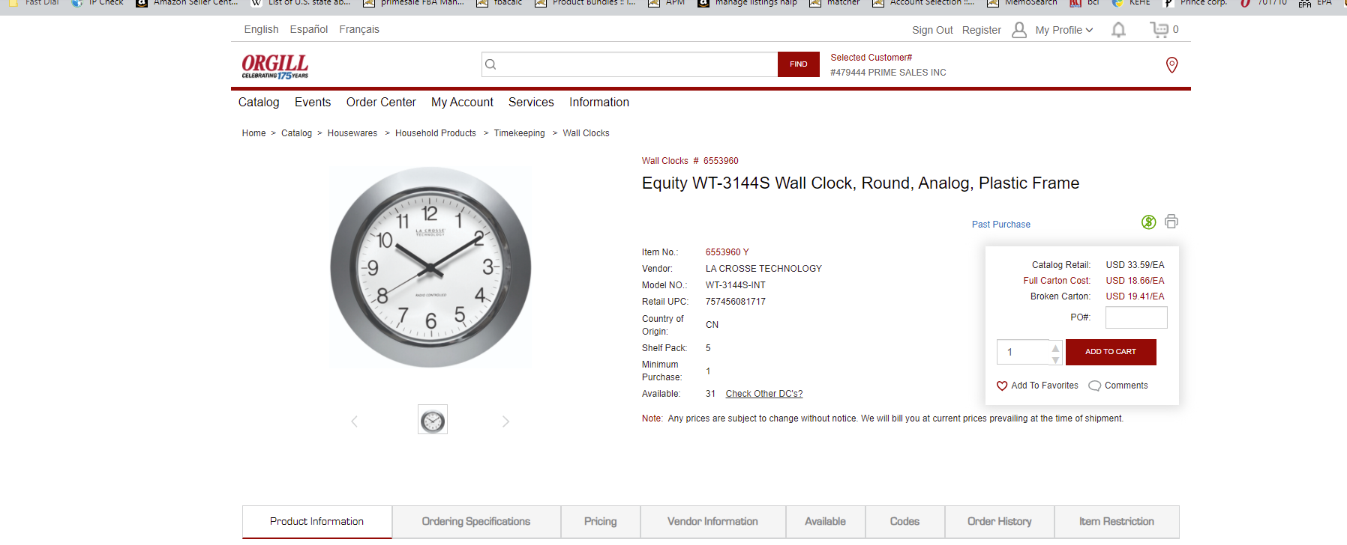  
  
9.add the required quantity to the cart and put the ordered quantity of goods in the apm in the new order field  
  
  
If, for example, we have several orders for the same product, then we add everything to the cart at once and in the apm, in one new order field of any of the orders for the same product, we write the total quantity of goods ordered. The orders added to the basket are marked with the color purple.  
  
If the product is already in the cart, and we need to add more, then orgill will show this when adding it:  
  
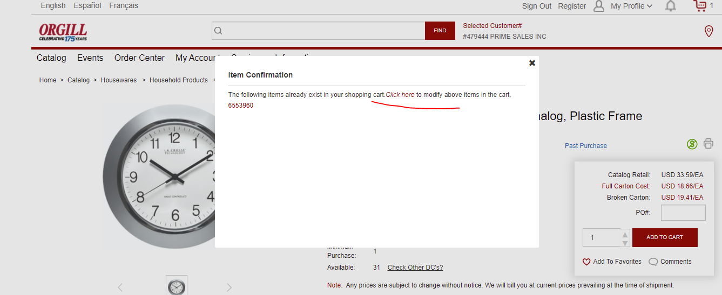  
  
In this case, you need to click on click here and then change the quantity in the basket to the required one.  
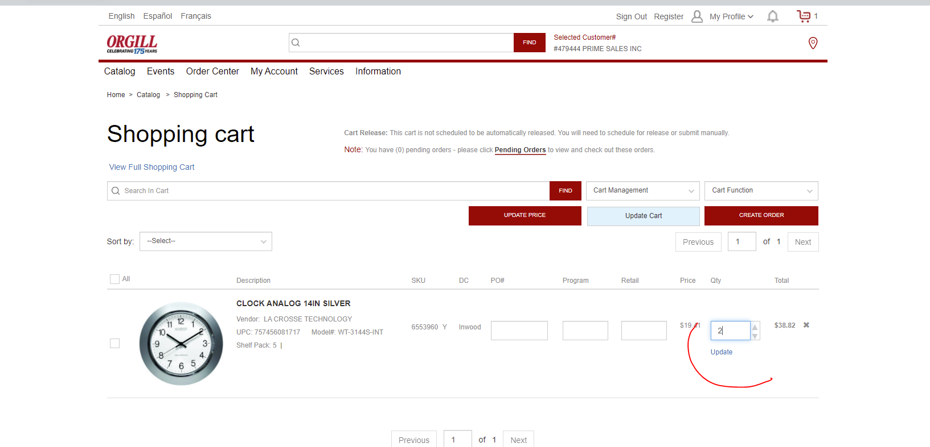  
  
And click update  
  
10. If in the apm we see remains,  
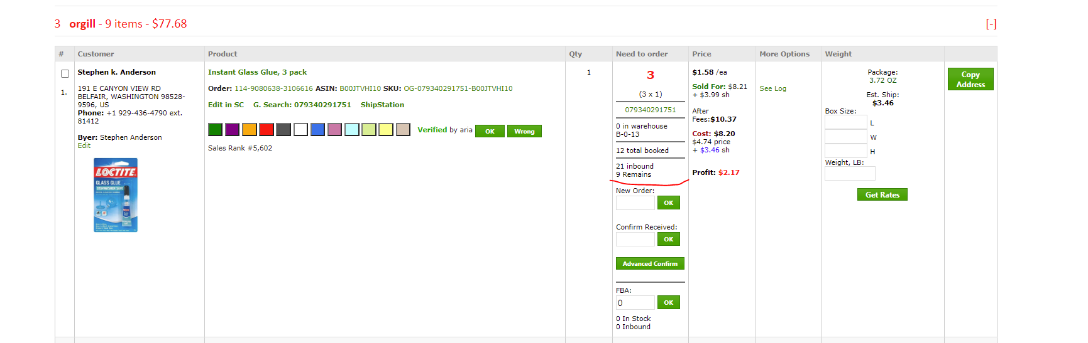  
then such a product does not need to be ordered. You just need to mark the order with purple color. In this example, we need 3 pieces for the order, but there are 9 remains. We do not order this, but simply mark purple.  
11. If there is a memo hold order   
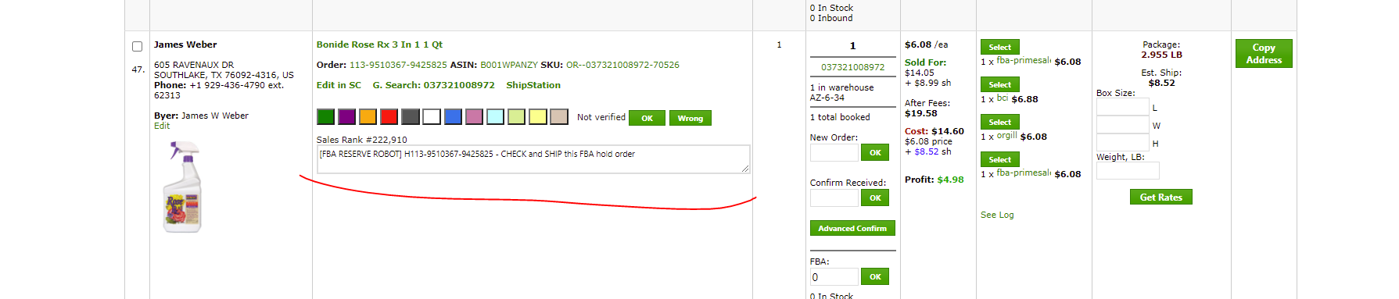 (the color in the apm order can be any - purple, blank, blue), change it to lime color, add orgill item to the basket, put the ordered quantity in the new order field in the apm. In the memo we write: ordered orgill need send from warehouse and cancel hold after.  
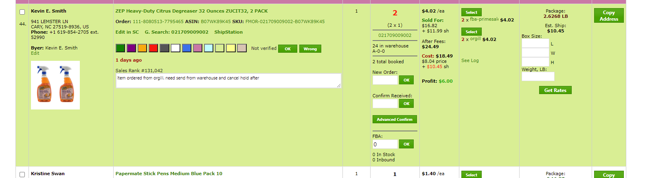  
  
When you have added and marked with colors everything you need, go to the cart on orgill,

click create order there.  
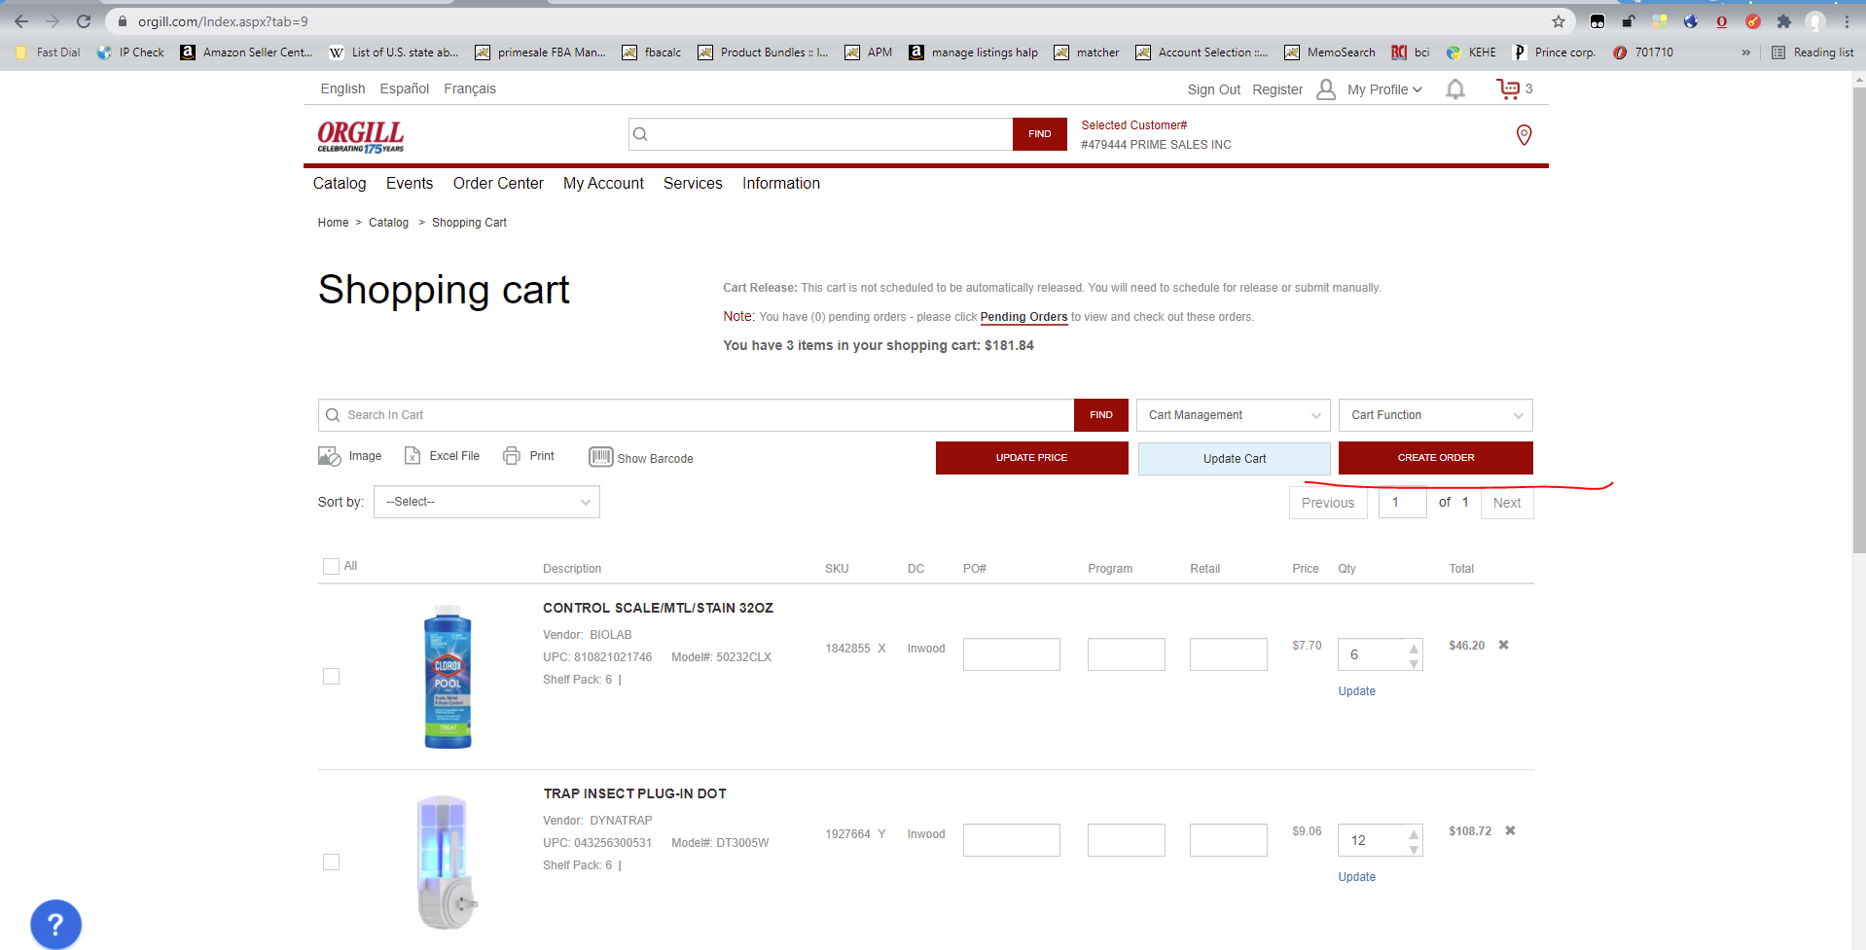  
Then [View/Edit](javascript:__doPostBack('ctl00$cphMainContent$ctl00$rptPendingOrder$ctl01$lblView',''))  
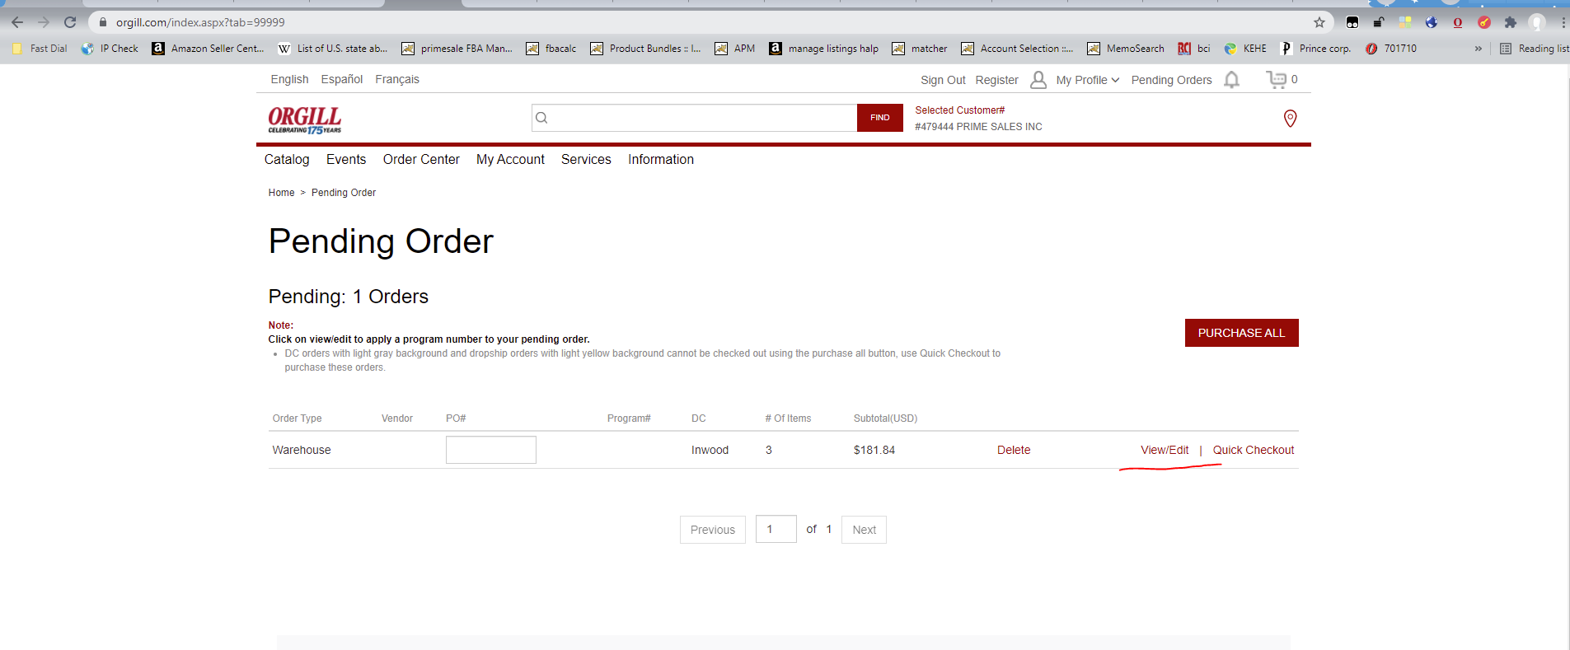  
  
At this stage we have to write in the PO number field. It is formed as follows – date (month, date, year and time - hours and minutes according to New York time. At the end of your signature)  
  
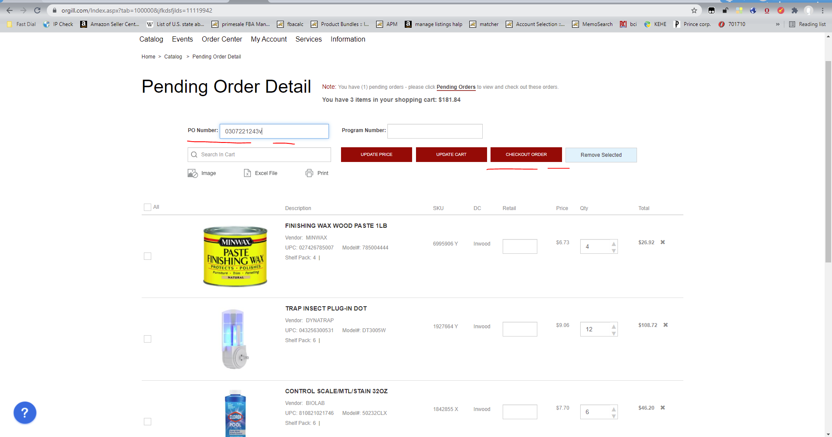  
In this example, the order was made on March 7, 22 at 12.43 New York time – we recorded

0307221243v.

We don't change anything else and click continue checkout  
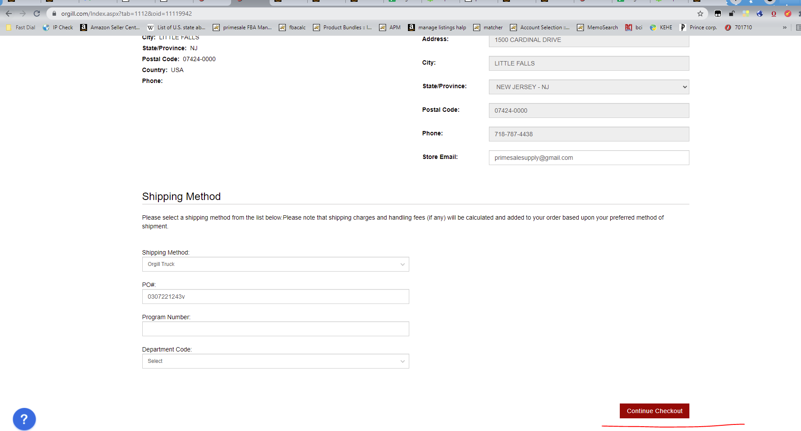  
Next click purchase  
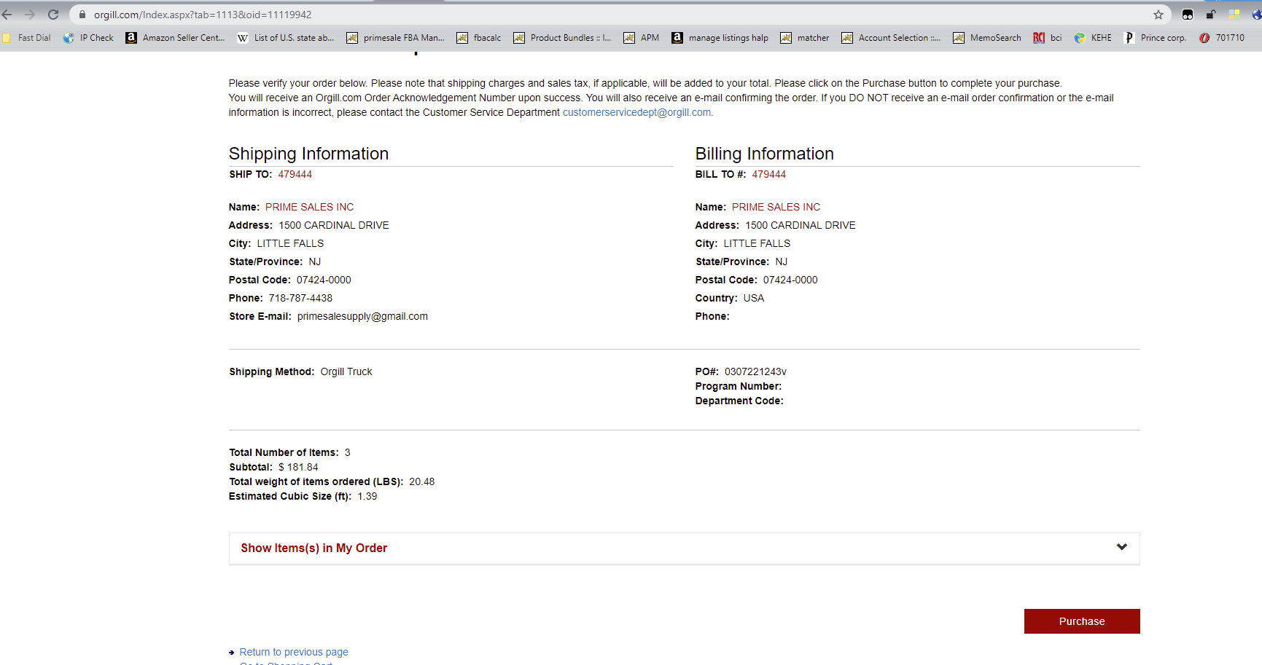  
  
After that we get the order confirmation.  
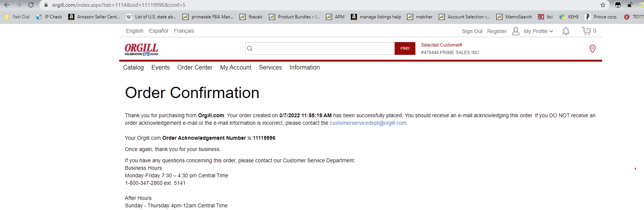  
You do not need to write this number in the memo.  
  
  
II. APM section warehouse - in stock  
  
Here we look through all the orders that are there, we are looking for memo hold orders  
  
We should mark this orders with lime color and write in a memo: need send from warehouse and cancel hold order after  
  
  
We don't do anything else here.  
  
  
III. APM section fba-primesale-amazon-us  
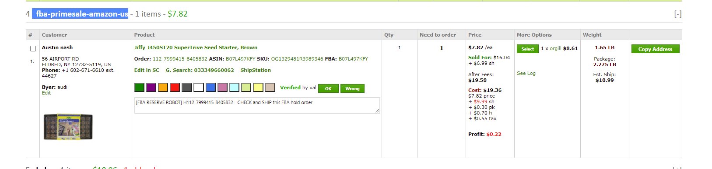  
These orders need to be sent from amazon fba to custmers directly  
  
Some of them have memos about hold orders like [FBA RESERVE ROBOT] H112-7999415-8405832 - CHECK and SHIP this FBA hold order  
  
These hold orders need to be confirmed to be sent to the buyer  
To do this, we are looking for a hold order from memo in the seller center by number (in this example, H112-7999415-8405832.) Link to the search:  
<https://sellercentral.amazon.com/orders-v3/search?page=1&q=&qt=orderid>  
  
We go into the order  
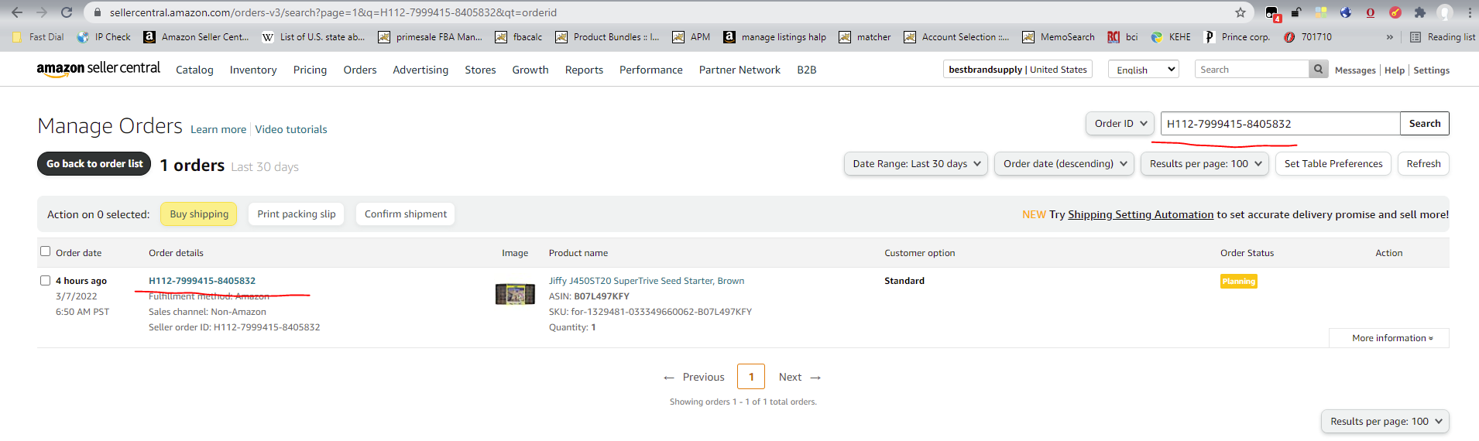  
Click edit this order  
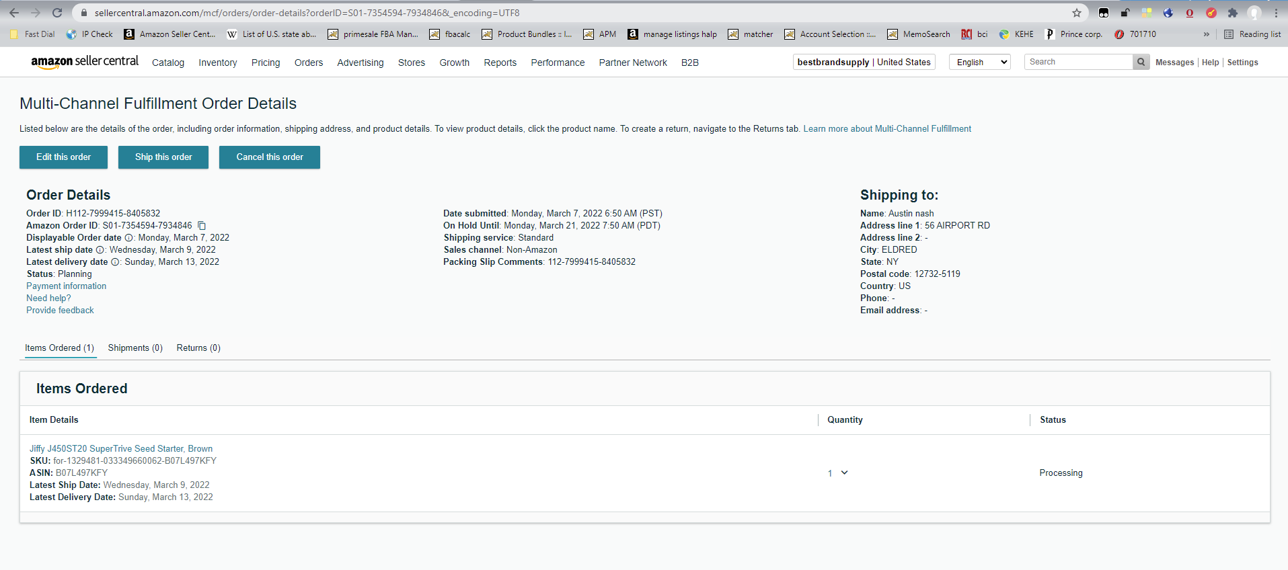  
Here we definitely put block amazon logistics  
  
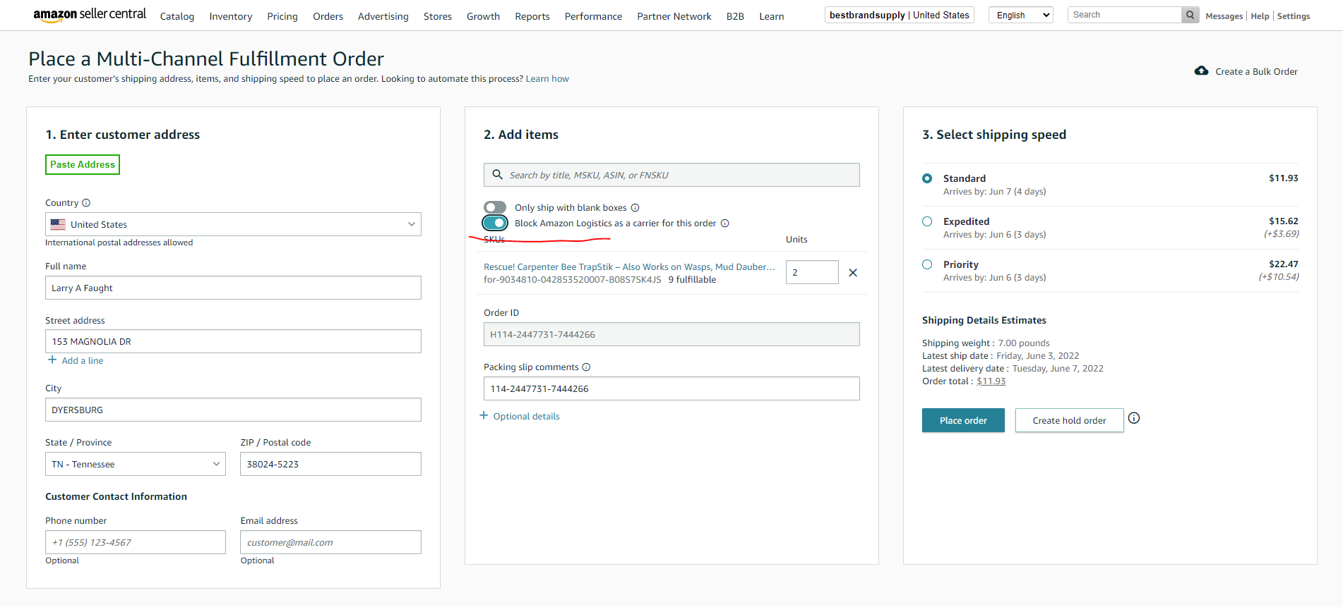  
and click place  
We receive the order number and the cost of delivery. The cost of delivery must be recorded in a memo along with the order number.  
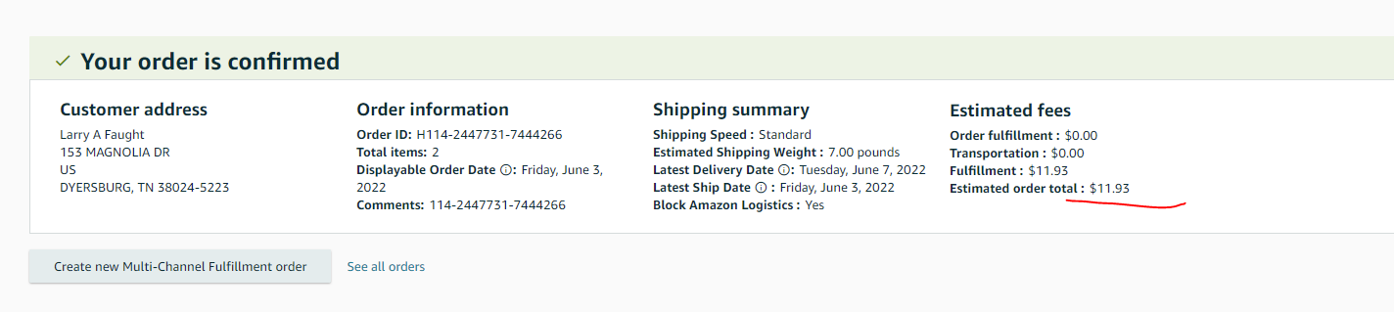  
But we definitely need an extended order number in the memo. To do this, click back in the browser  
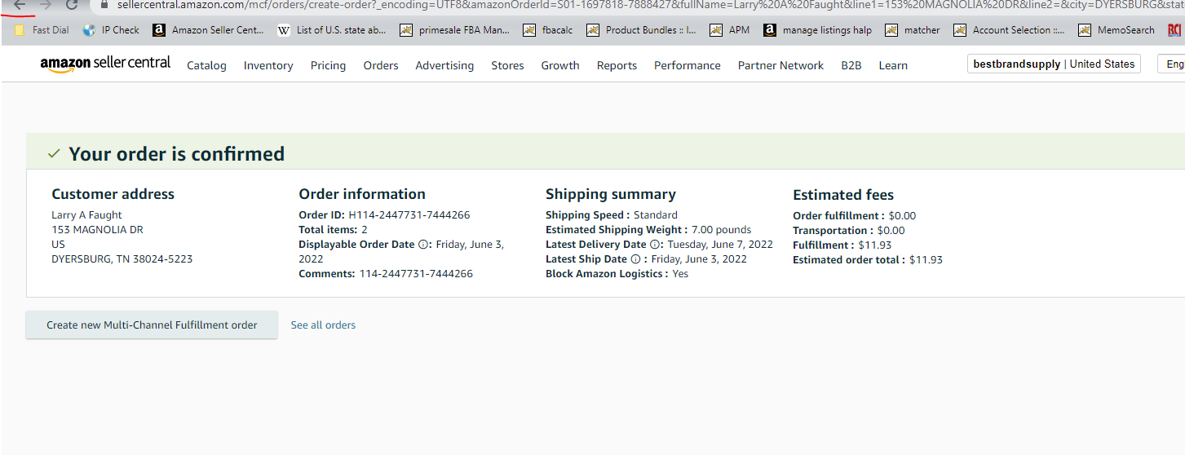  
And there we take the extended number like

Order ID: H114-2447731-7444266

Amazon Order ID: S01-1697818-7888427  
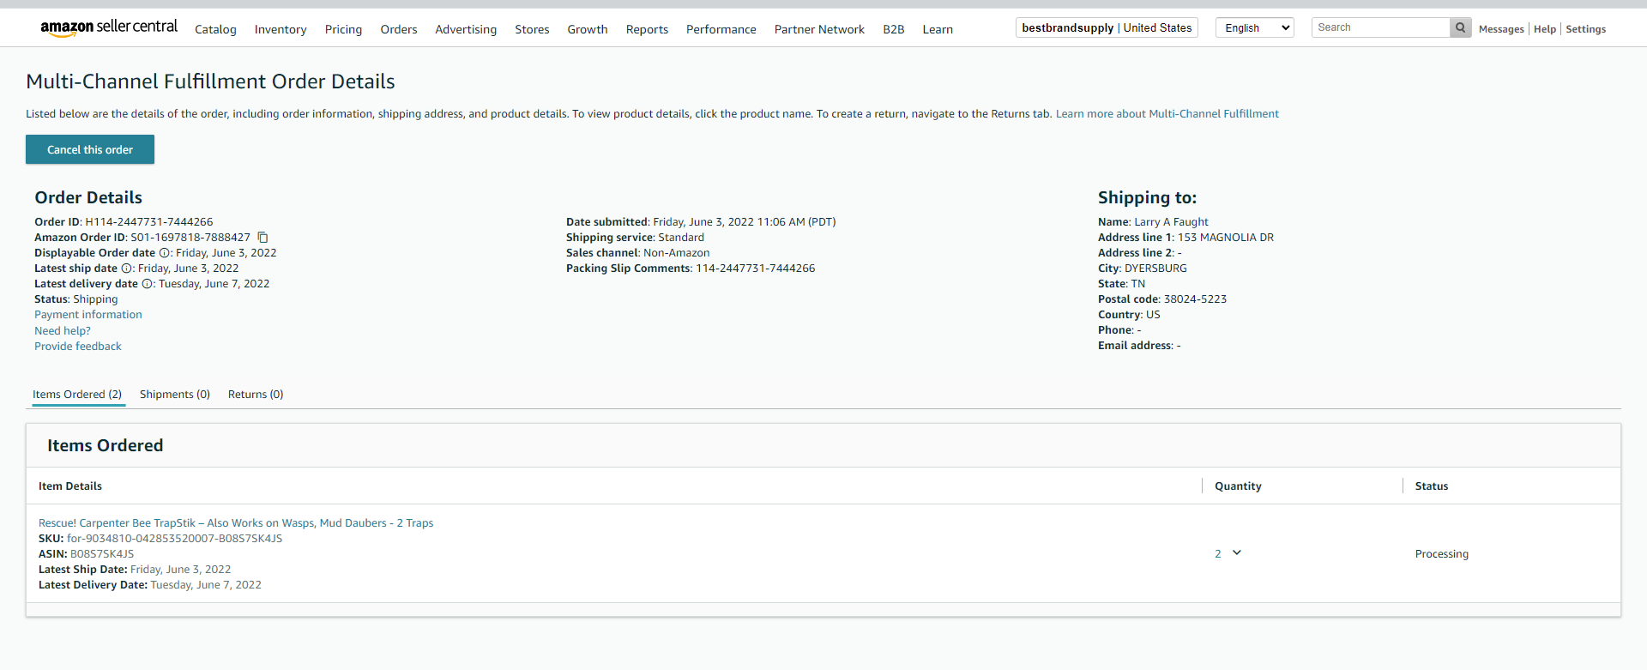  
We write it down in a memo along with the delivery price that we saw earlier, and put the yellow color to the order  
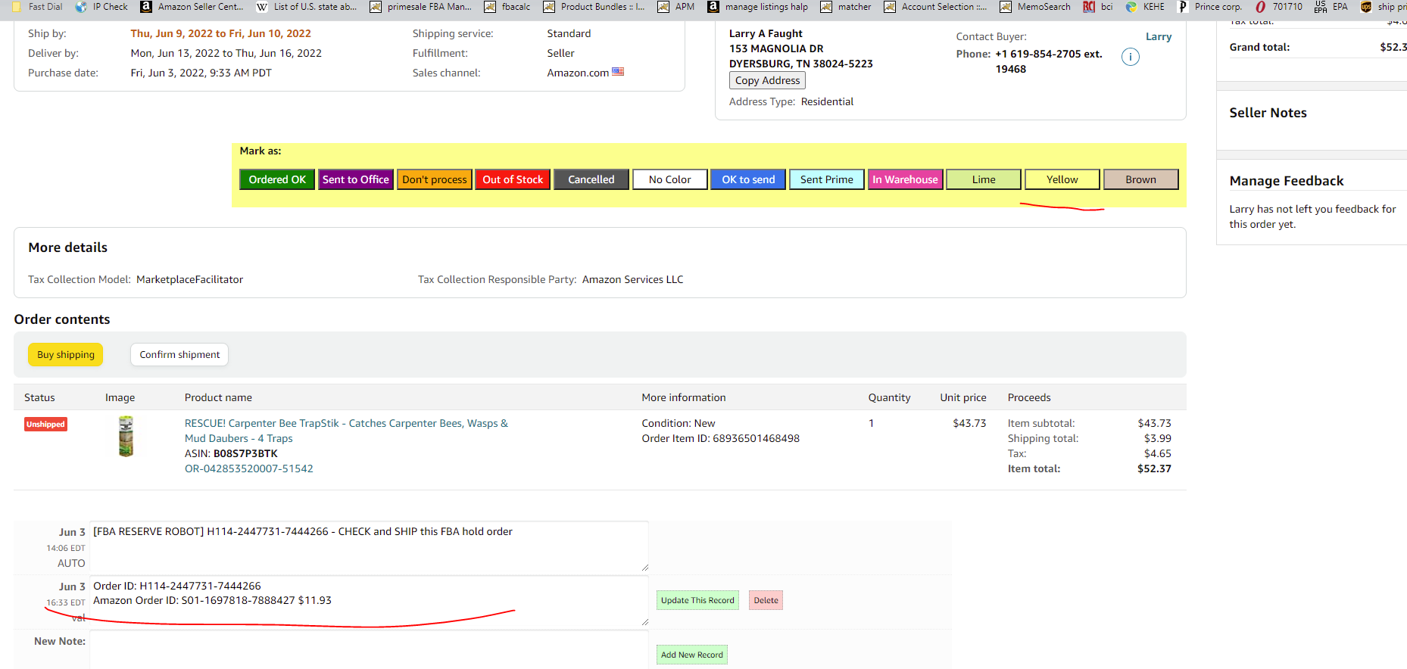  
Orders in which there is no hold in the memo, we buy from the fba manually, through a link to the product in the order.  
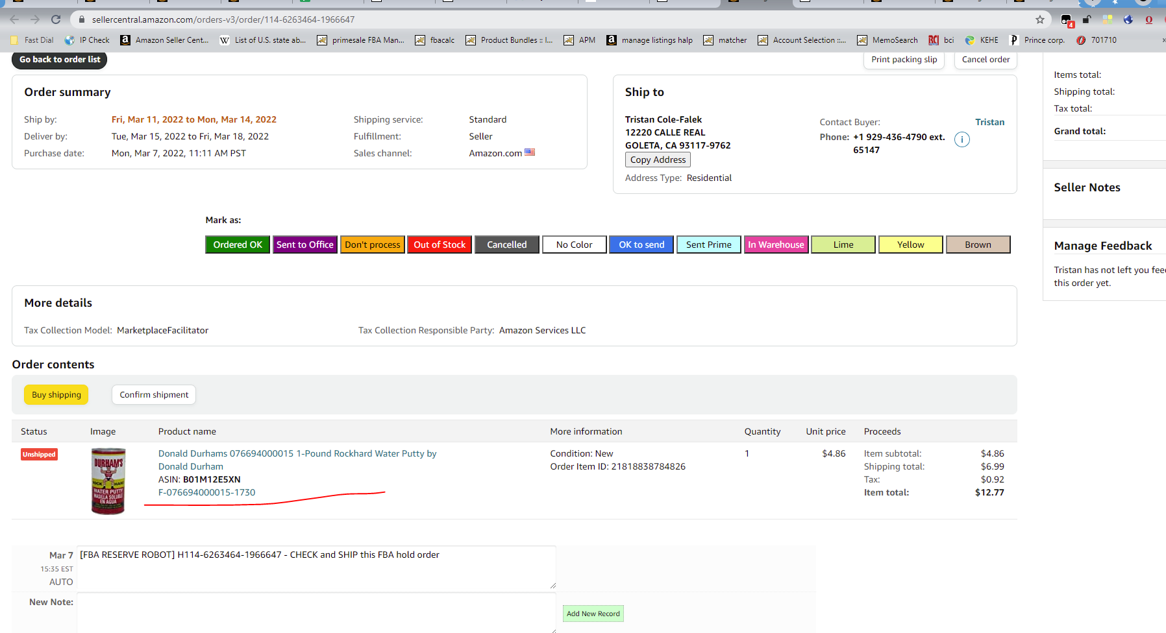  
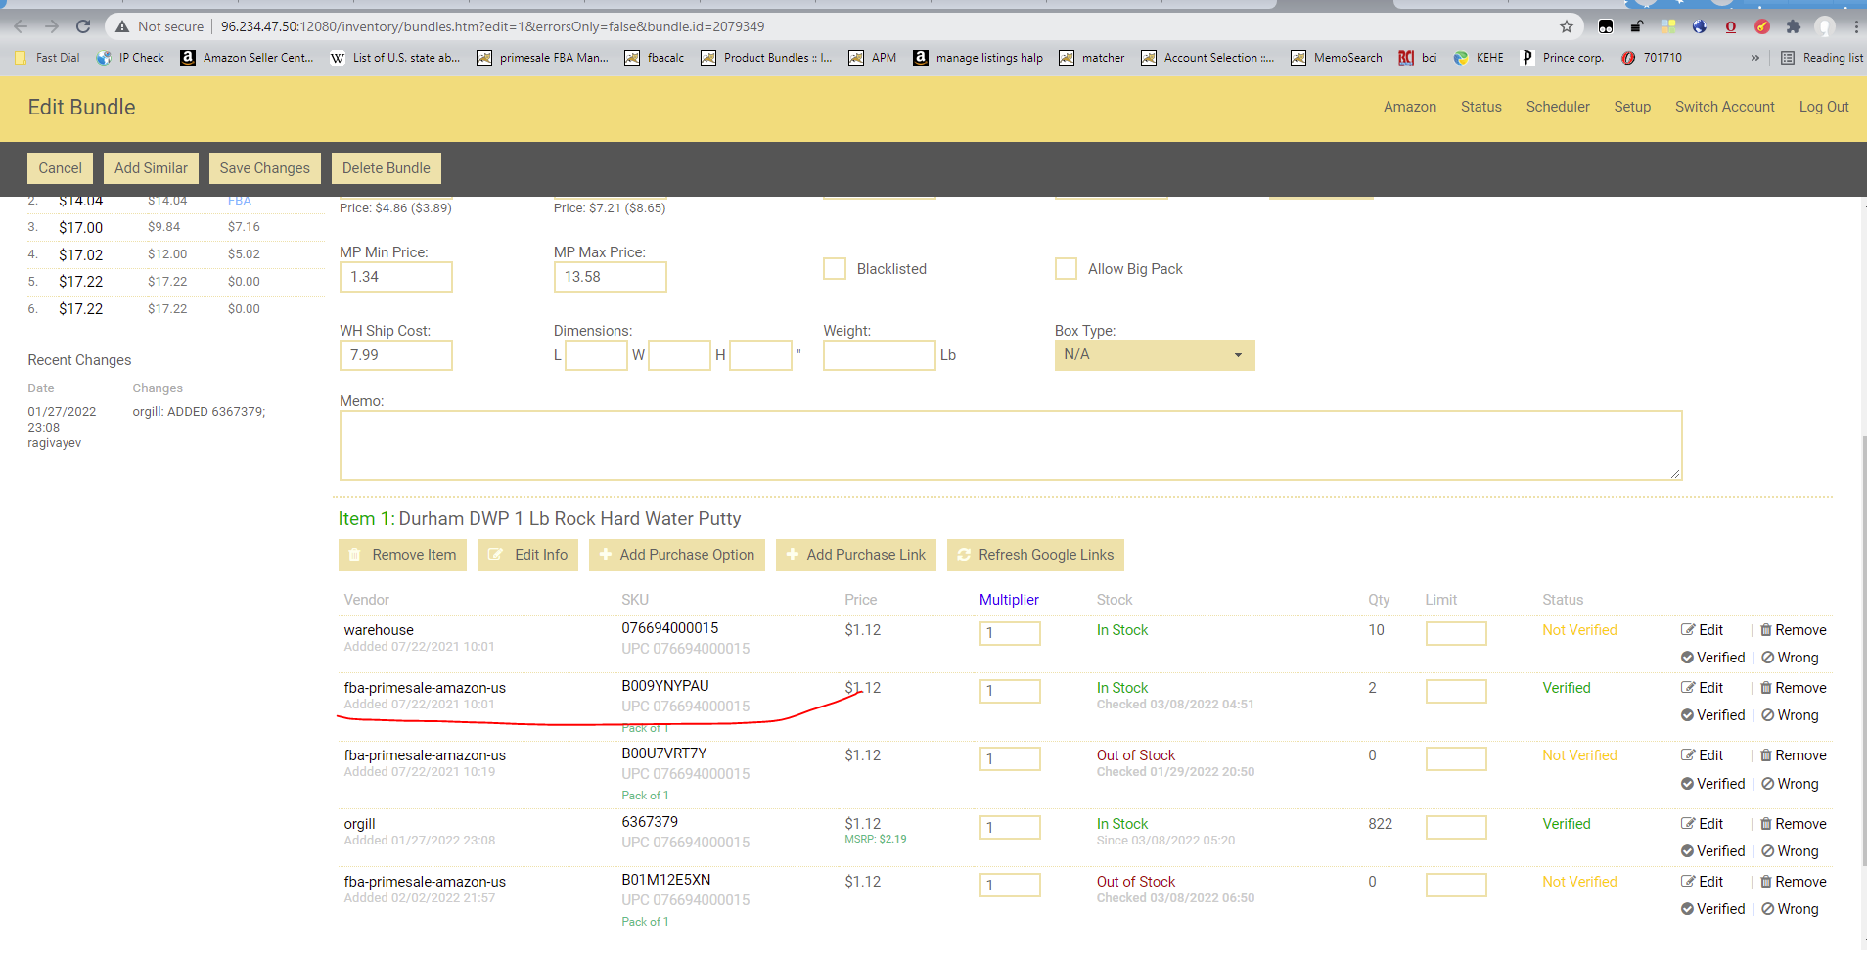  
There we create an order using menu action / create fulfillment order menu  
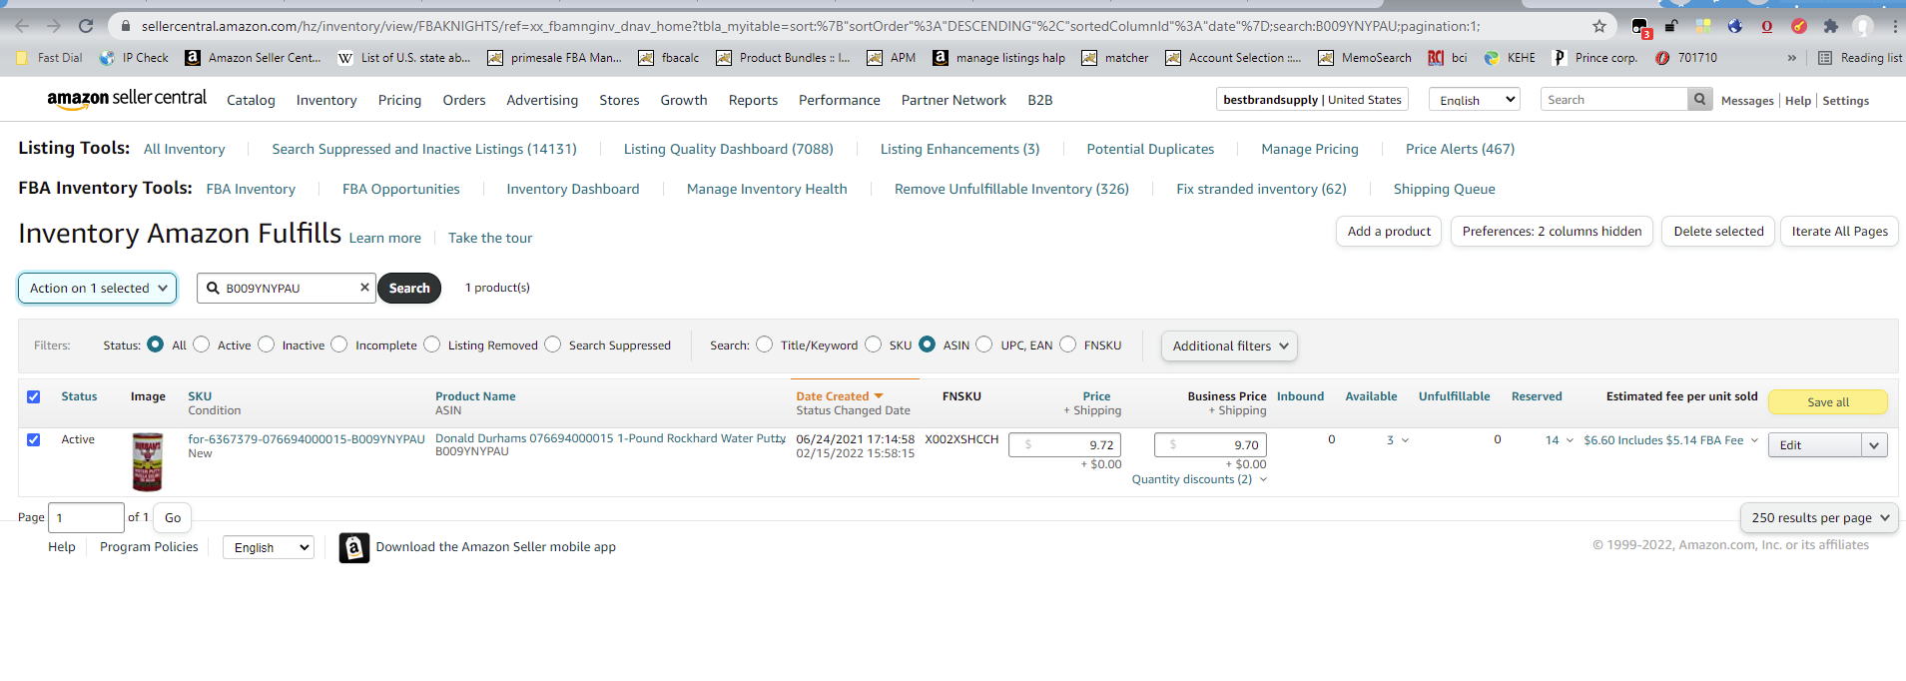  
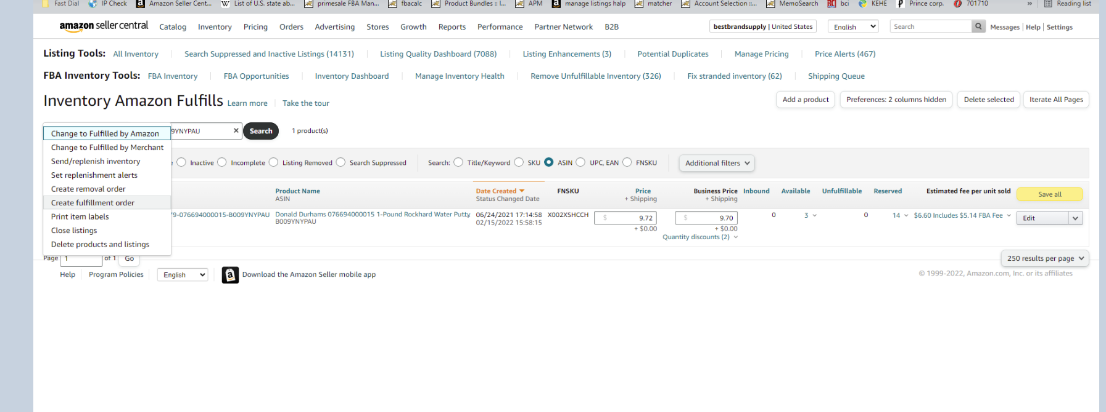  
We insert the address manually as usual or with the paste address button. But when using the paste address button, you need to edit each filled field (for example, add a space to the end of the line, otherwise Amazon does not count that the address is entered). It is also mandatory to put the number of our Amazon order from the apm in the packaging slip order id field.

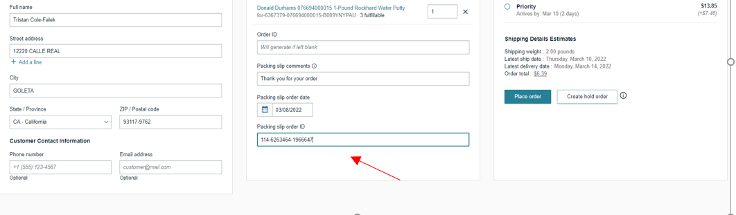  
Be sure to set block amazon logistics as well as for holds.  
After that, click place order and on the final screen we see the order number and the delivery price  
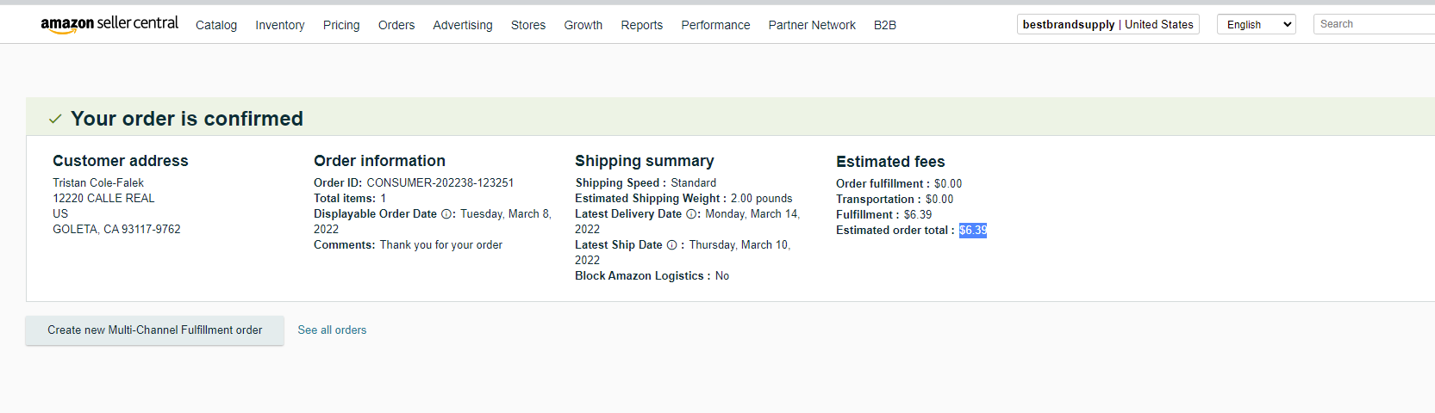  
We will also need the consumer number in full format, so we are looking for it in the same way as the holds in the link search below, take the full number and put it in the memo along with the delivery price. We set the color of the order yellow  
<https://sellercentral.amazon.com/orders-v3/search?page=1&q=&qt=orderid>